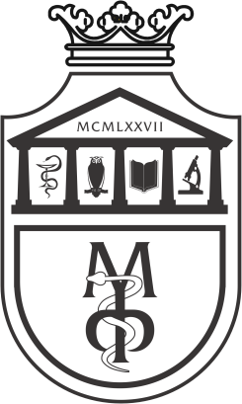
DISEASES

INFECTIOUS

CLINICAL MEDICINE 2

FOURTH YEAR OF STUDIES

School year 2025/2026.

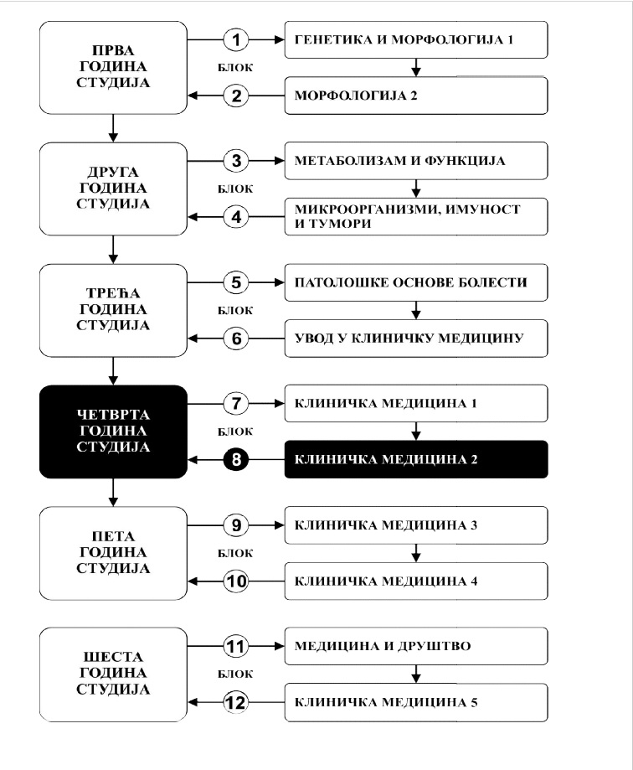
INSIGHT INTO CLINICAL MEDICINE
MEDICINE AND SOCIETY

PATHOLOGICAL BASICS OF DISEASES
MICROORGANISMS, IMMUNITY AND TUMORS
METABOLISM AND FUNCTION
GENETICS AND MORPHOLOGY 1
MORPHOLOGY 2
CLINICAL MEDICINE 2

CLINICAL MEDICINE 5

CLINICAL MEDICINE 4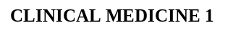 4

CLINICAL MEDICINE 3

CLINICAL MEDICINE 1

BLOCKK
BLOCKK
BLOCKK
BLOCKK
BLOCKK
BLOCKK
SIXT YEAR OF STUDY
FOURTH YEAR OF STUDY
FIFTH YEAR OF STUDY
THIRD YEAR OF STUDY
SECOND YEAR OF STUDY
FIRST YEAR OF STUDY

Course:

INFECTIOUS DISEASES

The course is evaluated with 6 ECTS. There are 6 hours of active classes per week (3 hours of lectures and 3 hours of work in a small group).

TEACHERS AND ASSOCIATES:

ord. | First and last name | Email address | Teacher's title
1. | Biljana Popovska-Jovićić | biljanapop@yahoo.com | Associate Professor, MD, PhD
2. | Sara Petrović | sara.nikolic.kv@gmail.com | Teaching Assistant, MD
3. | Sofija Sekulić Marković | sofija.sekulic91@gmail.com | Teaching Associate, MD
4. | Nemanja Đorđević | nemanja.djordjevic@fmn.kg.ac.rs | Teaching Assistant, MD
5. | Ivana Lešnjak | ivanalesnjak92@gmail.com | Facilitator, MD
6.

COURSE UNIT CONTENTS:

Module ord. | Module title | Number of weekly classes | Number of Lecture classes | Number of Work in a small group classes | Teacher-  head of the  module
1 | Infectious diseases as a discipline. Diagnosis and treatment of streptococcal and staphylococcal infections. Diagnosis and treatment of rash fever. Diagnosis and treatment of respiratory infections and enterovirosis. Diagnosis and treatment of viral neuroinfections. Diagnosis and treatment of bacterial neuroinfections. Diagnosis and treatment of intestinal infections. Diagnosis and treatment of acute and chronic viral hepatitis. Diagnosis and treatment of anaerobic infections and zoonoses. Diagnosis and treatment of herpes viral infections. Diagnosis and treatment of FUO and AIDS. Diagnosis and treatment of sepsis and viral hemorrhagic fevers. Diagnosis and treatment of parasitic and rickettsial diseases. Diagnosis and treatment of intrauterine and intrahospital infections. | 15 | 3 | 3
Σ 45+45=90

EXAMINATION METHODS:

The student masters the course by modules. The grade is equivalent to the number of points earned (see tables). Points are earned in three ways:

ACTIVITY DURING LECTURES: In this way, the student can gain up to 15 points by answering 2 exam questions from that week of classes and receiving 0-1 points in accordance with the demonstrated knowledge.

COLLOQUIUM (MODULE TEST): In this way, a student can earn up to 25 points according to the attached grading scheme by modules.

ORAL EXAMINATION: In this way, the student can gain 60 points, 10 points on the final skills test and 50 points on the oral exam.
The final skills test requires the student to take an anamnesis, perform a physical examination of the patient, interpret the findings, diagnose the patient (differential) and propose a therapeutic procedure.
If the student does not get more than 50% of the points on the final skills test, he cannot take the oral part of the exam. The oral part of the exam implies that the student orally answers five questions (each question is worth 0-10 points).
If the student does not get more than 50% of the points in the oral exam, he has not passed the exam.

MODULE |  | MAXIMUM POINTS
 |  | Activity during lectures | Module test | Oral examination | Σ
1 | Infectious diseases as a discipline. Basics of clinical careful history, epidemiologic feature, physical examination, laboratory, microbiological, serological analysis and appropriate radiographic procedure. Diagnosis and treatment of streptococcal and staphylococcal infections. Diagnosis and treatment of rash fever. Diagnosis and treatment of respiratory infections and enterovirosis. Diagnosis and treatment of viral neuroinfections. Diagnosis and treatment of bacterial neuroinfections. Diagnosis and treatment of intestinal infections. Diagnosis and treatment of acute and chronic viral hepatitis. Diagnosis and treatment of anaerobic infections and zoonoses. Diagnosis and treatment of herepes viral infections. Diagnosis and treatment of FUO and AIDS. Diagnosis and treatment of sepsis and viral hemorrhagic fevers. Diagnosis and treatment of parasitic and rickettsial diseases. Diagnosis and treatment of intrauterine and intrahospital infections. | 15 | 25 | 10+50 | 100

CONSULTATIVE TEACHING: Consultations can be scheduled with the head of the department, Prof Biljana Popovska Jovičić, MD, PhD (biljanapop@yahoo.com)

The final grade is formed as follows:

In order to pass the course, the student must obtain a minimum of 55 points, pass module test and pass the final oral exam.

To pass the module the student must:

1. obtains more than 50% points in that module
2. acquires more than 50% of the points provided for the activity during lectures
3. pass the module test, i.e. have more than 50% correct answers
4. obtains more than 50% points in the oral examination

Grading system

No. of points | Grade
0 - 50 | 5
51 - 60 | 6
61 - 70 | 7
71 - 80 | 8
81 - 90 | 9
91 - 100 | 10

TESTS BY MODULES

MODULE 1.
FINAL TEST
0-25 POINTS ЗАВРШНИ ТЕСТ

GRADING SYSTEM OF THE FINAL TEST
The test has 25 questions. Each question is worth 1 point.

LITERATURE:

Textbook name | Authors | Publisher | Availability in the faculty library
Harrison's Principles of Internal Medicine 21st Edition | Joseph Loscalzo, Anthony Fauci, Dennis Kasper, Stephen Hauser , Dan Longo and J. Larry Jameson | MC Graw Hill | Available
Netter’s infectious diseases 2en edition | Elaine c. Jong, Dennis l. Stevens | ELSEVIER | Available
Seidel's Guide to Physical Examination, 10th edition | Jane W. Ball & Joyce E. Dains & John A. Flynn & Barry S. Solomon & Rosalyn W. Stewart | ELSEVIER | Available

All lectures are available on the website of the Faculty of Medical Sciences: www.medf.kg.ac.rs
PROGRAM

TEACHING UNIT 1 (FIRST WEEK):
INFECTIOUS DISEASES AS A DISCIPLINE
3 school hours of lectures | 3 school hours of work in a small group
• Basics and importance of infectology  • The most important clinical syndromes  • Basic principles of diagnosis and therapy of infectious diseases  What a student should know:  • To acquire basic knowledge about the etiology of infectious diseases  • To acquire basic knowledge about the pathogenesis of infectious diseases  • To learn the basic forms of clinical manifestations of infectious diseases  • To review the basic principles of diagnosis and therapy of infectious diseases  • To learn the basic principles of immunoprophylaxis of infectious diseases | • Familiarizing students with history taking in infectious patients  • Acquaintance of students with the constituent parts of anamnesis  • Acquaintance of students with basic symptoms and signs of infectious diseases  • Taking anamnesis from patients by students  What a student should know:  • To independently take a complete medical history from the patient  • To know how to interpret the symptoms and signs of the disease present in the patient

TEACHING UNIT 2 (SECOND WEEK):
DIAGNOSIS AND TREATMENT OF STREPTOCOCCAL AND STAPHYLOCOCCAL INFECTIONS
3 school hours of lectures | 3 school hours of work in a small group
• Become familiar with the characteristics of streptococcal infections and their antigenic structure  • To learn the clinical forms of streptococcal infections  • Familiarize yourself with the way of diagnosing streptococcal infections  • Learn the principles of antibiotic therapy of streptococcal infections  • To learn the most significant clinical forms of staphylococcal infections  • Familiarize yourself with the use of antistaphylococcal antibiotics  What a student should know:  • To acquire knowledge about the etiology, pathogenesis, clinical picture, diagnosis and therapy of streptococcal and staphylococcal infections | • Acquaintance of students with objective patient examination and physical examination methods  • Acquaintance of students with general inspection of patients  What a student should know:  • To independently take anamnesis from the patient  • To master the techniques of physical examination of the oral cavity and regional lymph nodes  • To independently examine the patient's head and neck

TEACHING UNIT 3 (THIRD WEEK):
DIAGNOSIS AND TREATMENT OF RASH FEVER
3 school hours of lectures | 3 school hours of work in a small group
• Familiarize yourself with the etiology and pathogenesis of rash syndrome in infectious diseases  • Familiarize yourself with the most significant clinical characteristics of viral rash diseases  What a student should know:  • To acquire knowledge about etiology, epidemiology, pathogenesis, clinical picture, diagnosis, therapy, complications and prevention of the most common rash viral diseases | • Acquaintance of students with the basic morphological elements of rash  • Acquaint students with the importance of morphology, the method of outbreak and distribution of rash  What a student should know:  • To independently take anamnesis and perform an objective examination of the skin

TEACHING UNIT 4 (FOURTH WEEK):
DIAGNOSIS AND TREATMENT OF RESPIRATORY INFECTIONS AND ENTEROVIROSIS
3 school hours of lectures | 3 school hours of work in a small group
• Familiarize yourself with the characteristics of the most important respiratory infections (influenza, parainfluenza, adenovirosis, mumps)  • Familiarize yourself with the characteristics of the most significant enterovirus infections  What a student should know:  • To acquire knowledge about the etiology, pathogenesis, clinical picture, diagnosis and therapy of the most common respiratory infections  • To acquire knowledge about etiology, pathogenesis,  clinical picture, diagnosis and therapy of enterovirus diseases | • Acquaintance of students with an objective examination of the chest wall and respiratory organs  • Acquaintance of students with the most important symptoms and signs of disease in patients with diseases of the respiratory organs  What a student should know:  • To independently take anamnesis, perform an objective examination of the chest and respiratory organs in patients with symptoms of a respiratory infection

TEACHING UNIT 5 (FIFTH WEEK):
DIAGNOSIS AND TREATMENT OF VIRAL NEUROINFECTIONS
3 school hours of lectures | 3 school hours of work in a small group
• Getting to know the etiology, epidemiology, pathophysiology, clinical manifestations, diagnosis, therapy and complications of viral meningitis and meningoencephalitis  • Getting to know the specifics of herpetic encephalitis  What a student should know:  • To acquire knowledge about the etiology, epidemiology, pathogenesis, clinical picture, diagnosis, therapy, complications and prevention of the most common viral neuroinfections | • Introducing students to the objective examination of cranial nerves  • Introducing students to the performance of meningeal signs  • Familiarization of students with examination of gross motor power and sensibility of the patient  • Lumbar puncture observation  • Cytological examination of the cerebrospinal fluid  What a student should know:  • Basics of diagnosing viral neuroinfection  • Cytobiochemical interpretation during examination of cerebrospinal fluid  • Significance of CT and NMR of the endocranium in differential diagnoses of acute neuroinfections
TEACHING UNIT 6 (SIXTH WEEK):
DIAGNOSIS AND TREATMENT OF BACTERIAL NEUROINFECTIONS
3 school hours of lectures | 3 school hours of work in a small group
• Getting to know the pathophysiological and clinical characteristics of meningeal syndrome  • Getting to know the specifics of bacterial infections of the CNS, caused by certain bacteria (Pneumococcus, Haemophilus influenzae, Meningococcus, Tuberculosis bacillus)  • Familiarity with focal infections of the CNS  What a student should know:  • What are the specific symptoms related to CNS infections  • To acquire knowledge about etiology, epidemiology, pathogenesis, clinical picture, diagnosis, therapy,  complications and prevention of the most common bacterial neuroinfections | • Introducing students to the objective examination of cranial nerves  • Introducing students to the performance of meningeal signs  • Familiarization of students with examination of gross motor power and sensibility of the patient  • Lumbar puncture observation  • Cytological examination of the cerebrospinal fluid  What a student should know:  • Basics of diagnosing bacterial neuroinfection  • Cytobiochemical interpretation during examination of cerebrospinal fluid

TEACHING UNIT 7 (SEVENTH WEEK):

DIAGNOSIS AND TREATMENT OF INTESTINAL INFECTIONS
3 school hours of lectures | 3 school hours of work in a small group
• Getting to know the etiology and pathogenesis of intestinal infections  • Getting to know the clinical picture and basic therapeutic principles of intestinal infections  • Getting to know the most common non-invasive bacterial and viral infections of the digestive system  What a student should know:  • To acquire knowledge about etiology, epidemiology, pathogenesis, clinical picture, diagnosis, therapy, complications and prevention of the most common non-invasive intestinal infections | • Introducing students to an objective examination of the abdomen  • Introducing students to the methods of palpation of the liver and spleen  What a student should know:  • The most important symptoms and signs of infections of the digestive system  • Examination of the liver and spleen by palpation, percussion and auscultation

TEACHING UNIT 8 (EIGHTH WEEK):
DIAGNOSIS AND TREATMENT OF INTESTINAL INFECTIONS
3 school hours of lectures | 3 school hours of work in a small group
• Getting to know the etiology and pathogenesis of invasive intestinal infections  • Getting to know the clinical picture and basic therapeutic principles of invasive intestinal infections  • Getting to know the most common invasive bacterial infections of the digestive system  What a student should know:  • To acquire knowledge about the etiology, epidemiology, pathogenesis, clinical picture, diagnosis, therapy, complications and prevention of the most common invasive intestinal infections | • Use of antibiotics during intestinal infections  • Principles of diagnosis of intestinal infections  • Principles of patient rehydration during intestinal infections  What a student should know:  • Basic principles of diagnosis and treatment of intestinal infections

TEACHING UNIT 9 (NINTH WEEK):
DIAGNOSIS AND TREATMENT OF ACUTE AND CHRONIC VIRAL HEPATITIS
3 school hours of lectures | 3 school hours of work in a small group
• Getting to know the etiology, epidemiology and pathogenesis of acute and chronic viral hepatitis  • Acquaintance with clinical forms, diagnosis,  treatment and prevention of acute viral infections of the liver  • Fulminant hepatitis  • Getting to know the therapy and outcome of chronic viral hepatitis  What a student should know:  • To acquire knowledge about etiology, epidemiology, pathogenesis, clinical picture, diagnosis, therapy, complications and prevention of the most common viral infections of the liver | • Pathogenesis of icterus  • Serological diagnosis of viral liver infections  What a student should know:  • Physical findings in patients with viral liver infections  • Physical findings in patients with liver cirrhosis  • Etiological diagnosis of viral hepatitis

TEACHING UNIT 10 (TENTH WEEK):
DIAGNOSIS AND TREATMENT OF ANAEROBIC INFECTIONS AND ZOONOSES
3 school hours of lectures |  | 3 school hours of work in a small group
• Getting to know the etiology, epidemiology and pathogenesis, clinical picture, diagnosis, treatment and prevention of tetanus and botulism  • Acquaintance with etiology, epidemiology and  pathogenesis, clinical picture, diagnosis, treatment and prevention of the most important zoonoses (leptospirosis, anthrax, borreliosis, rabies, trichinellosis)  What a student should know:  • To acquire knowledge about etiology, epidemiology, pathogenesis, clinical picture, diagnosis, therapy,  complications and prevention of the most common anaerobic infections and zoonoses | • Stay in intensive care and familiarization with the principles of work  • Anti-tetanus protection  What a student should know:  • Anti-tetanus protection  • Anti-rabies protection  • Treatment of patients with a clinical picture of tetanus
TEACHING UNIT 11 (ELEVENTH WEEK):
DIAGNOSIS AND TREATMENT OF HERPES VIRAL INFECTIONS
3 school hours of lectures | 3 school hours of work in a small group
• General characteristics of herpes virus infections  • Clinical features, diagnosis and treatment of herpes simplex virus infections  • Cytomegalovirus infection  • Infectious mononucleosis  • Other clinical manifestations caused by herpes  viruses  What a student should know:  • To acquire knowledge about etiology, epidemiology, pathogenesis, clinical picture, diagnosis, therapy,  complications and prevention of herpes viral infections | • Examination of the oral cavity in patients with herpetic gingivostomatitis  • Examination of the oral cavity in patients with infectious mononucleosis  • Ultrasound examination of the abdomen in patients with infectious mononucleosis  What a student should know:  • Hematological findings in patients with infectious mononucleosis  • Serological diagnosis of infectious mononucleosis  • Complications of infectious mononucleosis

TEACHING UNIT 12 (TWELFTH WEEK):
DIAGNOSIS AND TREATMENT OF FUO AND AIDS
3 school hours of lectures | 3 school hours of work in a small group
• Definition, epidemiology, pathogenesis, natural course of HIV infection  • Opportunistic infections and opportunistic tumors  • Diagnosis of HIV infection and HAART therapy  • Definition of fever of unknown origin and division  What a student should know:  • To acquire knowledge about etiology, epidemiology, pathogenesis, clinical picture, diagnosis, therapy, complications and prevention of HIV infection  • To acquire knowledge about the diagnostic algorithm during the evaluation of an unclear febrile condition | • Treatment of patients with HIV infection  What a student should know:  • The most important symptoms and clinical signs of opportunistic infections and tumors in patients with AIDS  • Basic principles of HAART therapy  • CDC classification system of HIV infection

TEACHING UNIT 13 (THIRTEENTH WEEK):
DIAGNOSIS AND TREATMENT OF SEPSIS AND VIRAL HEMORRHAGIC FEVERS
3 school hours of lectures | 3 school hours of work in a small group
• Definition, etiology and pathogenesis of sepsis  • Clinical picture, physical findings, diagnosis and therapy of sepsis  • Septic shock – diagnosis and treatment  • Hemorrhagic fever with renal syndrome (HFRS), Crimean-Congo hemorrhagic fever  What a student should know:  • To acquire knowledge about the etiology, epidemiology, pathogenesis, clinical picture, diagnosis, therapy, complications of sepsis and the most common hemorrhagic fevers in our region | • Treatment of patients with sepsis  • Importance of taking and interpreting blood cultures  • Disseminated intravascular coagulation in infectious diseases  What a student should know:  • Conditions associated with sepsis  • Rational use of antibiotics
TEACHING UNIT 14 (FOURTEENTH WEEK):
DIAGNOSIS AND TREATMENT OF PARASITIC AND RICKETTSIAL DISEASES
3 school hours of lectures | 3 school hours of work in a small group
• Epidemiology, etiology, pathogenesis, clinical picture of malaria, amebiasis, leishmaniasis, spotted typhus, toxoplasmosis  What a student should know:  • To acquire knowledge about etiology, epidemiology, pathogenesis, clinical picture, diagnosis, therapy,  complications of the most common parasitic and rickettsial diseases | • Presentations of clinical cases of patients with parasitic infections  What a student should know:  • Basic principles of malaria diagnosis  • Basic principles of malaria treatment and prophylaxis

TEACHING UNIT 15 (FIFTEENTH WEEK):
DIAGNOSIS AND TREATMENT OF INTRAUTERINE AND INTRAHOSPITAL INFECTIONS
3 school hours of lectures | 3 school hours of work in a small group
• Intrauterine infections  • Nosocomial infections  • Infections in immunosuppressed persons  What a student should know:  • Definition and types of hospital infections  • Risk factors for hospital infections  • Measures to control hospital infections  • TORCH complex of causes of intrauterine infections | • Analysis of the most common hospital infections in UKC Kragujevac  What a student should know:  • Types of hospital infections  • Measures to control hospital infections  • Diagnosing and preventing intrauterine infections

LECTURE SCHEDULE

SCHEDULE OF PRACTICAL CLASSES

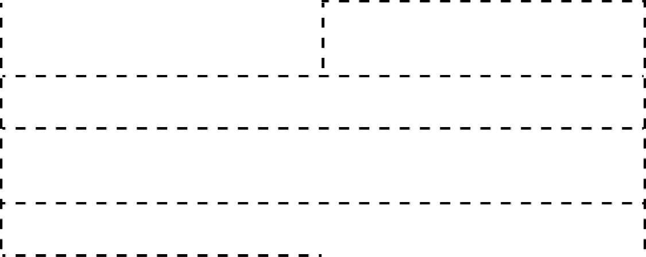
CLINIC FOR INFECTIOUS DISEASES

Schedule of classes and module tests

LESSON SCHEDULE FOR THE COURSE: INFECTIOUS DISEASES

Module | Week | Type | Method unit name | Teacher
1 | 1 | L | Infectious diseases as a discipline | Biljana Popovska-Jovićić
1 | 1 | SG |  | Sara Petrović  Nemanja Đorđević  Sofija Sekulić Marković
1 | 2 | L | Diagnosis and treatment of streptococcal and staphylococcal infections | Biljana Popovska-Jovićić
1 | 2 | SG |  | Sara Petrović  Nemanja Đorđević  Sofija Sekulić Marković
1 | 3 | L | Diagnosis and treatment of rash fever | Biljana Popovska-Jovićić
1 | 3 | SG |  | Biljana Popovska-Jovićić  Sara Petrović  Nemanja Đorđević  Sofija Sekulić Marković
1 | 4 | L | Diagnosis and treatment of respiratory infections and enterovirosis | Biljana Popovska-Jovićić
1 | 4 | SG |  | Sara Petrović  Nemanja Đorđević  Sofija Sekulić Marković
1 | 5 | L | Diagnosis and treatment of viral neuroinfections | Biljana Popovska-Jovićić
1 | 5 | SG |  | Sara Petrović  Nemanja Đorđević  Sofija Sekulić Marković
1 | 6 | L | Diagnosis and treatment of bacterial neuroinfections | Biljana Popovska-Jovićić
1 | 6 | SG |  | Sara Petrović  Nemanja Đorđević  Sofija Sekulić Marković
1 | 7 | L | Diagnosis and treatment of intestinal infections | Biljana Popovska-Jovićić

LESSON SCHEDULE FOR THE COURSE: INFECTIOUS DISEASES

Module | Week | Type | Method unit name | Teacher
1 | 7 | SG |  | Biljana Popovska-Jovićić  Sara Petrović  Nemanja Đorđević  Sofija Sekulić Marković
1 | 8 | L | Diagnosis and treatment of intestinal infections | Biljana Popovska-Jovićić
1 | 8 | SG |  | Sara Petrović  Nemanja Đorđević  Sofija Sekulić Marković
1 | 9 | L | Diagnosis and treatment of acute and chronic viral hepatitis | Biljana Popovska-Jovićić
1 | 9 | SG |  | Sara Petrović  Nemanja Đorđević  Sofija Sekulić Marković
1 | 10 | L | Diagnosis and treatment of anaerobic infections and zoonoses | Biljana Popovska-Jovićić
1 | 10 | SG |  | Biljana Popovska-Jovićić  Sara Petrović  Nemanja Đorđević  Sofija Sekulić Marković
1 | 11 | L | Diagnosis and treatment of herpes viral infections | Biljana Popovska-Jovićić
1 | 11 | SG |  | Sara Petrović  Nemanja Đorđević  Sofija Sekulić Marković
1 | 12 | L | Diagnosis and treatment of FUO and AIDS | Biljana Popovska-Jovićić
1 | 12 | SG |  | Sara Petrović  Nemanja Đorđević  Sofija Sekulić Marković
1 | 13 | L | Diagnosis and treatment of sepsis and viral hemorrhagic fevers | Biljana Popovska-Jovićić
1 | 13 | SG |  | Biljana Popovska-Jovićić  Sara Petrović  Nemanja Đorđević  Sofija Sekulić Marković

LESSON SCHEDULE FOR THE COURSE: INFECTIOUS DISEASES

Module | Week | Type | Method unit name | Teacher
1 | 14 | L | Diagnosis and treatment of parasitic and rickettsial diseases | Biljana Popovska-Jovićić
1 | 14 | SG |  | Biljana Popovska-Jovićić  Sara Petrović  Nemanja Đorđević  Sofija Sekulić Marković
1 | 15 | L | Diagnosis and treatment of intrauterine and intrahospital infections | Biljana Popovska-Jovićić
1 | 15 | SG |  | Biljana Popovska-Jovićić  Sara Petrović  Nemanja Đorđević  Sofija Sekulić Marković
 |  | MT | MODULE TEST
 |  | OE | ORAL EXAMINATION (June exam period)

List of abbreviations: L - Lecture
SG – Work in a small group
MT – Module test
OE – Oral examination

